* Please use same fonts it's already sent.
* Use Original logo ( already sent )
* Increase logo size
* Decrease Padding as XD:

|  |  |
| --- | --- |
| XD | Html |
|  |  |

* Make 2 – 3 Pictures and content to test the slider Animation while moving (it should auto move as well)
* Decrease padding between texts :

|  |  |
| --- | --- |
| XD | Html |
|  |  |

* Bad Idea to use Images here:

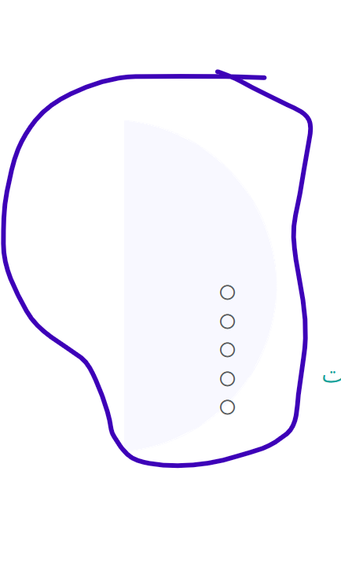

* Reduce Padding :

|  |  |
| --- | --- |
| XD | Html |
|  |  |

* Check and Compare the style:

|  |  |
| --- | --- |
| XD | Html |
|  |  |

* Why here we used A pic as a background



* Check and Compare the style:

|  |  |
| --- | --- |
| XD | Html |
|  |  |

* Check and Compare the style:

|  |  |
| --- | --- |
| XD | Html |
|  |  |

* Why using 3 Sliders ( each line moving ) it should Auto moving with button if customer need to move (See PDF):



* Check and Compare the style:

|  |  |
| --- | --- |
| XD | Html |
|  |  |

* Decrease footer height + text padding + Use original logo file and increase the size
* Menu Style + font + color.. you can show the underline while hover

|  |  |
| --- | --- |
| XD | Html |
|  |  |
|  |  |

* If you can't make it same then show it as normal XD then make it normal and show 4 boxes in a line :



* Under line make it same as XD and While hovering it should underline for Whole text (Animation)

|  |  |
| --- | --- |
| XD | Html |
|  |  |

* Decrease Padding as XD and check the style as well :

|  |  |
| --- | --- |
| XD | Html |
|  |  |

* Decrease Padding as XD and check the style of button + make 2 -3 pic and content to test the slider moving .. :

|  |  |
| --- | --- |
| XD | Html |
|  |  |

* Padding + Style :

|  |  |
| --- | --- |
| XD | Html |
|  |  |

* Page3 its slider with Arrow :



* Why we using Pics? + style looking Bad



* Toggle not working :



* Check and compare :

|  |  |
| --- | --- |
| XD | Html |
|  |  |